LEGO MINDSTORM

Following a line edge

# Bluetooth Setup

The Bluetooth should be setup before the students arrive. This should take at least 30 minutes.

1. Turn on the laptops first, you don’t need to log in just yet.
2. Turn on a single robot by pressing the middle button on the face.
3. Press right 3 times to access the settings menu
4. Select Bluetooth and make sure it is on. The option for Ipad/Ipod has to be off.
5. Open the Mindstorm software on the laptop.
6. Start a new program by pressing the plus button in the top left hand corner.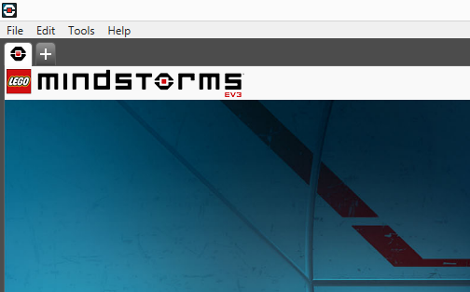
7. Select the connection options in the bottom right. 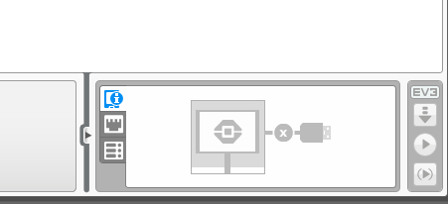
8. Select the name of the EV3 you have turned on. You can find the name at the top of the screen on the EV3. Sometimes it might be “EV3” but it should have a SCEM name with a number.
9. The first prompt is on the EV3, just select the connecting options and leave the password as 1234.
10. If it is the first time the EV3 is being paired with this laptop you will go back and forth from the EV3 to the laptop selecting the connect option.

# Knowing the Blocks

## Move – Steering

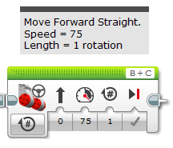

Left Motor Port

Right Motor Port

Direction of Movement

Speed of Movement

Brake when finished

Number of Rotations/Degrees/ Seconds

MENU

## 

Move the robot forward in a straight line using at least 3 different speeds.

Here is an example of 3 different speeds. Negative numbers will make it go backwards.

To play the program you press the play button at the bottom right.

MAKE SURE THEY DON’T FALL OFF THE TABLE.

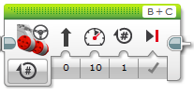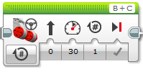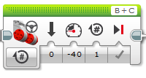



Use the button on the robot to run the program on the ground.

All the program names will by default be “program”. If there are a few programs with the same name feel free to show the kids how to change the name. Double click the name tab at the top left of the screen.

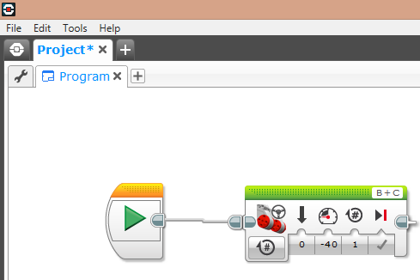

After they press the play button on the laptop their new program will be downloaded and then they can use it.

To stop a program press the top left button on the robot face.

## 

Turn the robot left then right in the 1 program.

This is left than right. Feel free to give the kids 5 minutes to experiment with turns and straight blocks.

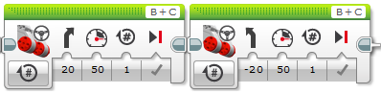

## 

Use a loop to make the robot complete a continuous circle.

Explain that everything that inside the loop will happen forever.

The loop is located in the orange “Flow Control” section.

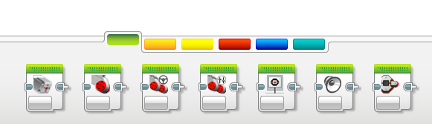

Once the block is in the loop they have to change the menu to “ON”.

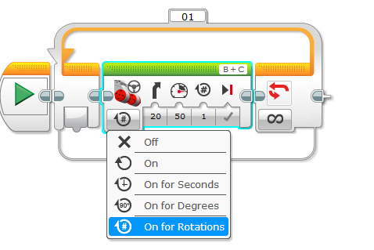

This is what the program should look like. They can use any speed or angle.

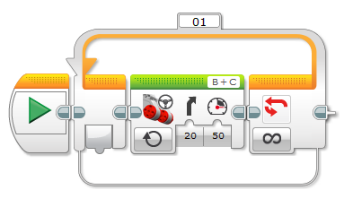

## 

Use a switch, detecting the different light value to follow the line.

Put a switch in the loop and make sure to change the menu of the switch to what’s shown in the picture.

In the top of the switch is right and left in the bottom. It doesn’t matter which is in what as long as they’re different.

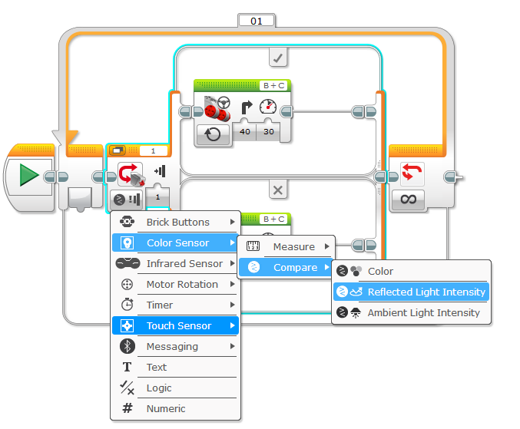

50 should work fine for the light value.

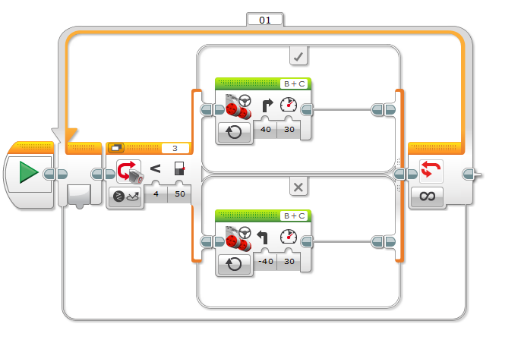

The kids will be changing the speed and angle at which to turn to find the best values to follow the line.

## 

Use another switch to get past the yellow obstacles.

They can get past the yellow type by doing this. If you have time get them to add the second switch and try it.

The option for the second switch is to measure colour.

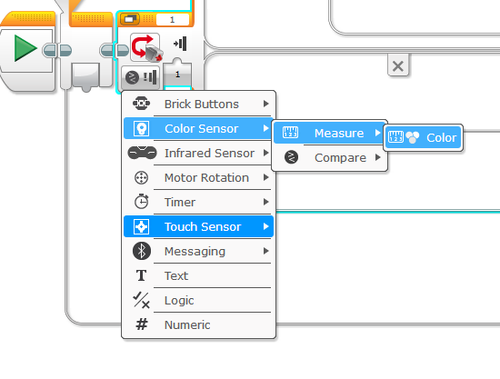

This is the answer:

Note to change the default dote to the no colour sign and the black at the top to yellow.

